Figure 1: Relationships between the classes and text files

|  |
| --- |

**Functionality of each class:**

* GUI Class: Creates the main UI for users to enter data. Passes inputted data into designated text files. Data is divided by “|” in the text files to sort different categories of each run.
* Text files: ​​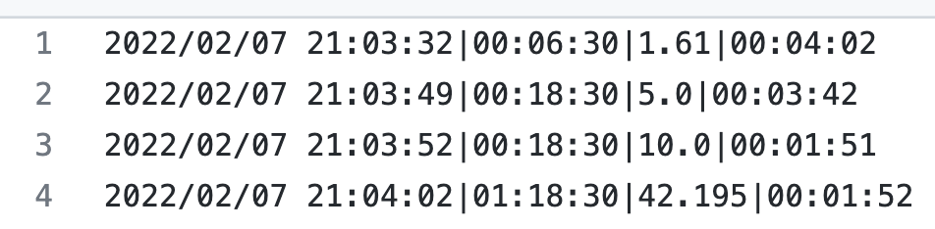
* History Class: Creates the Running Log UI and takes data from the text files to create a JTable displaying the run log. Calculations of streaks and PR are also displayed in this window.
* Data Class: Includes methods that are necessary for the functionality of the other two classes.

Figure 2 UML diagram for classes.

|  |
| --- |

**User Interface Prototype**

Figure 3: Main UI for entering running Data

|  |
| --- |

Main UI that will allow users to enter their running data.

* The Record Run button will process user inputted data and store it into a text file.

Figure 3: Running Log UI for entering running Data:

|  |
| --- |

Run Log Panel will allow users to view their previous runs as well as their PRs and Streak.

* Different PRs will be displayed based on different distances.

**Process Description**

Figure 4: Recording Runs Flowchart

|  |
| --- |

Figure 5: Streak-Counting System Flowchart

|  |
| --- |

Figure 6: PR Calculating System Flowchart

|  |
| --- |

Figure 7: Find longest Distance Flowchart

|  |
| --- |

Figure 7: Display Running Stats Flowchart

|  |
| --- |

* Runs are stored in different text files so that it is easier to display sorted runs on the table.
* Storing Runs in separate text files also allows Personal records to be calculated easily.

Figure 8: Writing and Retrieving Data Flowchart

|  |
| --- |

**Text Files**

Specific Distances:

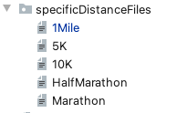

* All files are .txt files

All Distances:



* All files are .txt files

Streak:



* streakFile.txt: stores an integer that represents the running streak.

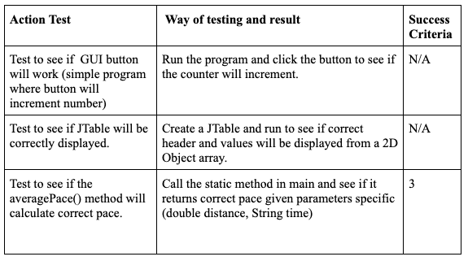

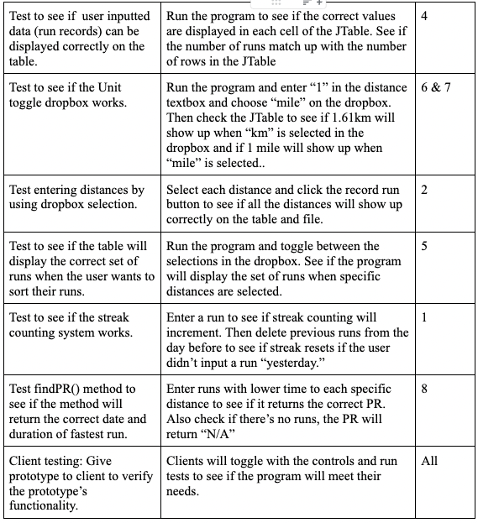

Word Count: 192